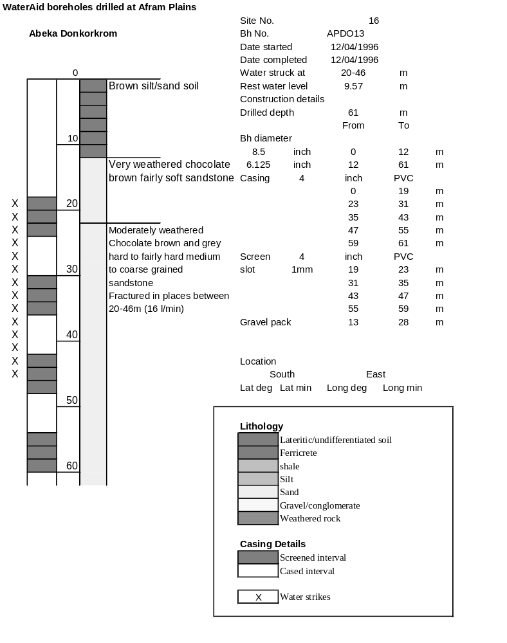

Ghana | Test pumping
Borehole No. |  | APDO13
Hole No |  | 16
Village |  | Abeka-Donkokrum
Date |  | 24/04/1996
Point above GL |  | 0.5 | m
Pump depth |  | 38 | m
SWL |  | 10.07 | m
Start Time |  | 13:30
Drawdown test |  |  |  |  | Recovery test
time | pwl (m) | Q l/min | dd | sc | Time | wl (m) | s' | t/t'
0.00 | 10.07 | 19.00 | 0.00 |  | 0.00 | 25.44 | 15.37
1.00 | 14.00 | 19.00 | 3.93 | 4.83 | 1.00 | 21.57 | 11.50 | 181.00
2.00 | 14.40 | 19.00 | 4.33 | 4.39 | 2.00 | 17.93 | 7.86 | 91.00
3.00 | 14.64 | 19.00 | 4.57 | 4.16 | 3.00 | 15.00 | 4.93 | 61.00
4.00 | 14.80 | 19.00 | 4.73 | 4.02 | 4.00 | 13.18 | 3.11 | 46.00
5.00 | 14.93 | 19.00 | 4.86 | 3.91 | 5.00 | 12.00 | 1.93 | 37.00
6.00 | 15.00 | 19.00 | 4.93 | 3.85 | 6.00 | 11.40 | 1.33 | 31.00
7.00 | 15.04 | 19.00 | 4.97 | 3.82 | 7.00 | 10.99 | 0.92 | 26.71
8.00 | 15.07 | 19.00 | 5.00 | 3.80 | 8.00 | 10.76 | 0.69 | 23.50
9.00 | 15.09 | 19.00 | 5.02 | 3.78 | 9.00 | 10.50 | 0.43 | 21.00
10.00 | 15.10 | 19.00 | 5.03 | 3.78 | 10.00 | 10.42 | 0.35 | 19.00
11.00 | 15.20 | 19.00 | 5.13 | 3.70 | 12.00 | 10.37 | 0.30 | 16.00
12.00 | 15.60 | 19.00 | 5.53 | 3.44 | 14.00 | 10.30 | 0.23 | 13.86
13.00 | 15.86 | 19.00 | 5.79 | 3.28 | 16.00 | 10.26 | 0.19 | 12.25
14.00 | 16.05 | 19.00 | 5.98 | 3.18 | 18.00 | 10.24 | 0.17 | 11.00
15.00 | 16.18 | 19.00 | 6.11 | 3.11 | 20.00 | 10.24 | 0.17 | 10.00
16.00 | 16.28 | 19.00 | 6.21 | 3.06 | 22.00 | 10.22 | 0.15 | 9.18
17.00 | 16.34 | 19.00 | 6.27 | 3.03 | 24.00 | 10.20 | 0.13 | 8.50
18.00 | 16.40 | 19.00 | 6.33 | 3.00 | 26.00 | 10.19 | 0.12 | 7.92
19.00 | 16.44 | 19.00 | 6.37 | 2.98 | 28.00 | 10.18 | 0.11 | 7.43
20.00 | 16.47 | 19.00 | 6.40 | 2.97 | 30.00 | 10.16 | 0.09 | 7.00
22.00 | 16.56 | 19.00 | 6.49 | 2.93 | 35.00 | 10.14 | 0.07 | 6.14
24.00 | 16.60 | 19.00 | 6.53 | 2.91 | 40.00 | 10.13 | 0.06 | 5.50
26.00 | 16.62 | 19.00 | 6.55 | 2.90 | 45.00 | 10.13 | 0.06 | 5.00
28.00 | 17.69 | 19.00 | 7.62 | 2.49 | 50.00 | 10.12 | 0.05 | 4.60
30.00 | 18.10 | 19.00 | 8.03 | 2.37 | 60.00 | 10.10 | 0.03 | 4.00
35.00 | 18.55 | 19.00 | 8.48 | 2.24 | 70.00 | 10.10 | 0.03 | 3.57
40.00 | 18.62 | 19.00 | 8.55 | 2.22 | 80.00 | 10.09 | 0.02 | 3.25
45.00 | 18.70 | 19.00 | 8.63 | 2.20 | 90.00 | 10.07 | 0.00 | 3.00
50.00 | 19.10 | 19.00 | 9.03 | 2.10 | 100.00 | 10.06 | -0.01 | 2.80
55.00 | 19.60 | 19.00 | 9.53 | 1.99 | 110.00 | 10.06 | -0.01 | 2.64
60.00 | 20.00 | 19.00 | 9.93 | 1.91 | 120.00 | 10.05 | -0.02 | 2.50
70.00 | 21.05 | 19.00 | 10.98 | 1.73
80.00 | 21.71 | 19.00 | 11.64 | 1.63
90.00 | 22.31 | 19.00 | 12.24 | 1.55
100.00 | 22.72 | 19.00 | 12.65 | 1.50
110.00 | 23.04 | 19.00 | 12.97 | 1.46
120.00 | 23.42 | 19.00 | 13.35 | 1.42
130.00 | 23.70 | 19.00 | 13.63 | 1.39
140.00 | 24.11 | 19.00 | 14.04 | 1.35
160.00 | 24.86 | 19.00 | 14.79 | 1.28
180.00 | 25.44 | 19.00 | 15.37 | 1.24

